**3.9 Deployment Diagram**

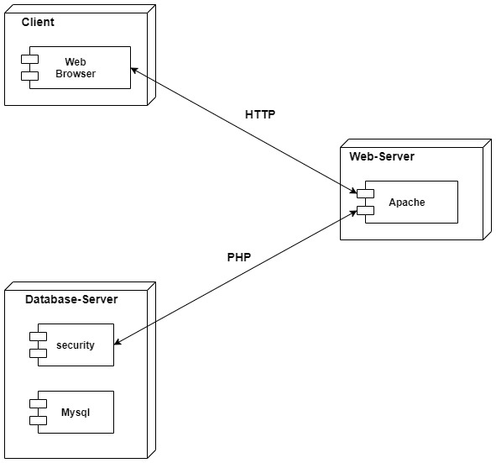

**3.10 Module Specification**

**1. Job Seeker Module:**

This module provides functionalities for job seekers. Applicants can post their resumes with personal and professional details. They can also update the resume as frequently as required. The applicant can also browse through the present vacancies available. Job seekers can also get mail alerts when they selected by recruiters.

**2. Company Module:**

This module provides functionalities related to companies. Companies can post jobs details and update the details as and when necessary. Companies can search through applicant resumes based on different requirements.

**2. Admin Module:**

This Module provides administrator related functionalities. Administrator maintains the profiles of applicants and companies.

**3.12 Web Site Map Diagram**

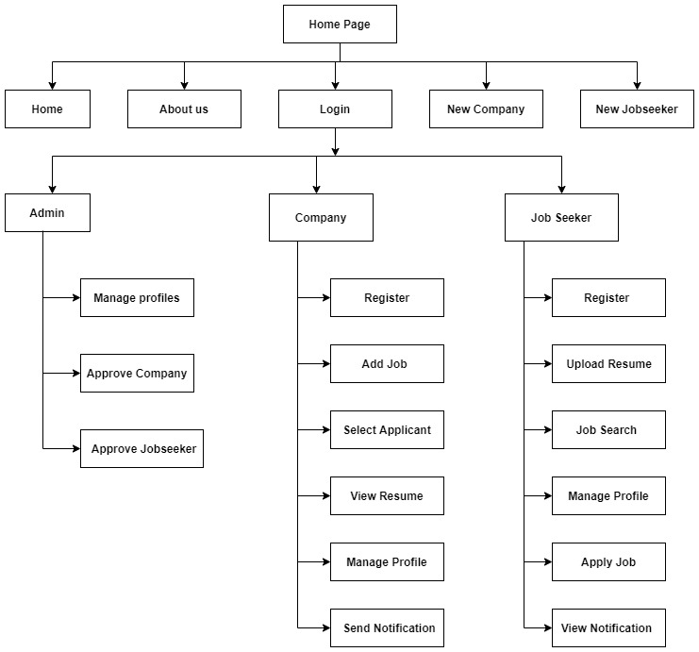

**3.14 Data Dictionary Diagram**

|  |  |  |  |  |
| --- | --- | --- | --- | --- |
| **Sr.no** | **Column name** | **Data type** | **Size** | **Description** |
| 1 | AID | Integer | 11 | Stores Admin ID of Admin in admin login Table. |
| 2 | admin_email | Varchar | 111 | Stores Admin Email of Admin in admin login Table. |
| 3 | admin_pass | Varchar | 111 | Stores password of Admin in admin login Table. |
| 4 | admin_username | Varchar | 111 | Stores Admin Username of Admin in admin login Table. |
| 5 | company_id | Integer | 11 | Stores Company id of Company in company Table. |
| 6 | company | Varchar | 111 | Stores company name of company in company table |
| 7 | des | Varchar | 111 | Stores description of company job in company Table. |
| 8 | City | Varchar | 111 | Stores City of jobseeker in city Table. |
| 9 | State | Varchar | 111 | Stores State of jobseeker in state Table. |
| 10 | Country | Varchar | 111 | Stores Country of jobseeker in Country Table. |
| 11 | Job_id | Integer | 11 | Stores job_id of job in all_jobs Table. |
| 12 | Customer_email | Varchar | 111 | Stores Email of JobSeeker in all_jobs Table. |
| 13 | Job_title | Varchar | 111 | Stores job title of job in all_jobs Table. |
| 14 | des | Varchar | 111 | Stores desription of job in all_jobs Table. |
| 15 | keyword | Varchar | 111 | Stores keyword of job keywords in all_jobs Table. |
| 16 | category | Varchar | 111 | Stores category of job in all_jobs Table. |
| 17 | jid | Integer | 11 | Stores Jobseekers id of Jobseeker in jobseeker Table. |
| 18 | email | Varchar | 111 | Stores email of a jobseeker in jobseeker Table. |
| 19 | password | Varchar | 111 | Stores password of a jobseeker in jobseeker Table. |
| 20 | first_name | Varchar | 255 | Stores First Name of Jobseeker in jobseeker Table. |
| 21 | last_name | Varchar | 255 | Stores Last Name of Jobseeker in jobseeker Table. |
| 22 | dob | Date | - | Stores Date of Birth of Jobseeker in jobseeker Table. |
| 23 | mobile_number | Integer | 10 | Stores Mobile Number of a jobseeker in jobseeker Table. |
| 24 | cid | Integer | 11 | Stores Category id of Category in job_category Table. |
| 25 | category | Varchar | 111 | Stores Category of a Job in job_category Table. |
| 26 | des | Varchar | 111 | Stores description of job category in job_category Table. |
| 27 | jaid | Integer | 11 | Stores Job Apply id of job apply in job_apply Table. |
| 28 | first_name | Varchar | 111 | Stores First Name of jobseeker in job_apply Table. |
| 29 | last_name | Varchar | 111 | Stores Last Name of a jobseeker in job_apply Table. |
| 30 | dob | Date | - | Stores date of birth of a jobseeker in job_apply Table. |
| 31 | file | Varchar | 111 | Stores Resume of a Jobseeker in job_apply Table. |
| 32 | id_job | Integer | 11 | Stores job id of a Job in job_apply Table. |
| 33 | job_seeker | Varchar | 111 | Stores Email of a JobSeeker in job_apply Table. |
| 34 | pid | Integer | 11 | Stores Profile ID of a Profile in Profiles Table. |
| 35 | img | Varchar | 111 | Stores Image of a Jobseeker in Profiles Table. |
| 36 | name | Varchar | 111 | Stores Name of a Jobseeker in Profiles Table. |
| 37 | dob | DateTime | 111 | Stores date of birth of a Jobseeker in Profiles Table. |
| 38 | number | Integer | 10 | Stores Mobile Number of a Jobseeker in profiles Table. |
| 39 | email | Varchar | 111 | Stores Email a jobseeker in profiles Table. |
| 40 | FeedbackID | Integer | 5 | Stores FeedbackID details in Feedback Table. |
| 41 | Ratings | Integer | 5 | Stores Ratings details in Feedback Table. |
| 42 | Description | Varchar | 111 | Stores description details in Feedback Table. |
| 43 | Date | DateTime |  | Stores Feedback date in Feedback Table. |
| 44 | Time | DateTime |  | Stores Feedback time in Feedback Table. |
| 45 | J_ID | Integer | 5 | Stores foreign key of Jobseeker ID in Feedback Table. |

**3.15 Table Specification**

1. **JobSeeker**

|  |  |  |  |  |
| --- | --- | --- | --- | --- |
| **Sr.no** | **Column name** | **Data type** | **Size** | **Constraint** |
| 1 | jid | Integer | 11 | Primary key |
| 2 | email | Varchar | 111 | Not null |
| 3 | password | Varchar | 111 | Not null |
| 4 | First_name | Varchar | 255 | Not null |
| 5 | Last_name | Varchar | 255 | Not null |
| 6 | dob | Integer | 111 | Not null |
| 7 | Mobile_number | Integer | 10 | Not null |
| 8 | City | Varchar | 10 | Not null |
| 9 | State | Varchar | 20 | Not null |
| 10 | Country | Varchar | 20 | Not null |

1. **Admin_Login**

|  |  |  |  |  |
| --- | --- | --- | --- | --- |
| 1 | AdminID | Integer | 11 | Primary key |
| 2 | Admin_email | Varchar | 111 | Not null |
| 3 | Admin_password | Varchar | 111 | Not Null |
| 4 | Admin_username | Varchar | 111 | Not Null |

1. **All_Jobs**

|  |  |  |  |  |
| --- | --- | --- | --- | --- |
| **Sr.no** | **Column name** | **Data type** | **Size** | **Constraint** |
| 1 | Job_id | Integer | 11 | Primary key |
| 2 | Customer_email | Varchar | 111 | Not null |
| 3 | Job_title | Varchar | 111 | Not null |
| 4 | Des | Varchar | 255 | Not null |
| 5 | Country | Varchar | 255 | Not null |
| 6 | State | Varchar | 111 | Not null |
| 7 | City | Varchar | 111 | Not null |
| 8 | Keyword | Varchar | 111 | Not null |
| 9 | Category | Varchar | 111 | Not null |

1. **Company**

|  |  |  |  |  |
| --- | --- | --- | --- | --- |
| 1 | Company_ID | Integer | 5 | Primary Key |
| 2 | Company | Integer | 5 | Foreign Key |
| 3 | Des | Integer | 5 | Not null |

1. **Job_Post**

|  |  |  |  |  |
| --- | --- | --- | --- | --- |
| **Sr.no** | **Column name** | **Data type** | **Size** | **Constraint** |
| 1 | Jobpost_id | Integer | 11 | Primary key |
| 2 | Company_id | Integer | 11 | Not null |
| 3 | Job_title | Varchar | 111 | Not null |
| 4 | City_id | Varchar | 111 | Not null |
| 5 | Post | Varchar | 111 | Not null |
| 6 | Skills required | Integer | 111 | Not null |
| 7 | Salary | Integer | 10 | Not null |

1. **Job_category**

|  |  |  |  |  |
| --- | --- | --- | --- | --- |
| 1 | JCID | Integer | 11 | Primary Key |
| 2 | Category | Varchar | 111 | Not null |
| 3 | Des | Varchar | 111 | Not Null |

1. **Job_apply**

|  |  |  |  |  |
| --- | --- | --- | --- | --- |
| **Sr.no** | **Column name** | **Data type** | **Size** | **Constraint** |
| 1 | jaid | Integer | 11 | Primary key |
| 2 | First_name | Varchar | 111 | Not null |
| 3 | Last_name | Varchar | 111 | Not null |
| 4 | dob | date | 111 | Not null |
| 5 | file | Varchar | 111 | Not null |
| 6 | Id_job | Integer | 11 | Not null |
| 7 | Job_seeker | Varchar | 111 | Not null |

1. **Profiles**

|  |  |  |  |  |
| --- | --- | --- | --- | --- |
| 1 | pid | Integer | 11 | Primary key |
| 2 | img | Varchar | 111 | Not null |
| 3 | name | Varchar | 111 | Not Null |
| 4 | dob | DateTime | 111 | Not Null |
| 5 | number | Integer | 111 | Not null |
| 6 | email | Varchar | 111 | Not null |

1. **City**

|  |  |  |  |  |
| --- | --- | --- | --- | --- |
| 1 | City_id | Integer | 5 | Primary key |
| 2 | State_id | Varchar | 20 | Foreign key |
| 3 | City_name | Varchar | 20 | Not Null |

1. **Country**

|  |  |  |  |  |
| --- | --- | --- | --- | --- |
| 1 | Country_ID | Integer | 5 | Primary key |
| 2 | Country_name | Varchar | 20 | Not null |

1. **State**

|  |  |  |  |  |
| --- | --- | --- | --- | --- |
| 1 | State_ID | Integer | 5 | Primary key |
| 2 | Country_id | Varchar | 20 | Foreign key |
| 3 | State_name | Integer | 20 | Not null |

1. **Feedback**

|  |  |  |  |  |
| --- | --- | --- | --- | --- |
| 1 | FeedbackID | Integer | 5 | PrimaryKey |
| 2 | Ratings | Integer | 5 |  |
| 3 | Description | Varchar | 50 | Not null |
| 4 | Date | DateTime |  | Not null |
| 5 | Time | DateTime |  | Not null |
| 6 | jobseekerID | Integer | 5 | Foreign Key |

**3.16 Test Procedures and Implementations:**

**TESTING**

Testing plays a vital role in success of the system. System testing makes logical assumption that if all parts of the system are correct, the goal will be successfully achieved. Once program code has been deployed, testing begins. The testing process focuses on the logical internals of the software, ensuring that all the statements have been tested, and on the functional externals, that is conducted tests to uncover errors and ensure that defined input will produce actual results that agree with required results.

**TYPES OF TESTING:**

1. Unit testing
2. Integration testing
3. Validation testing
4. System testing
5. Negative testing

|  |  |  |  |  |  |
| --- | --- | --- | --- | --- | --- |
| **Test Case ID** | **Objectives** | **Action** | **Expected Result** | **Actual Result** | **Status** |
| 1 | New User Login | New Candidate tries to Login | Username does not exist | Username does not exist | Pass |
| 2 | Wrong Password | Provide Wrong password | Username / Password does not exist | Username / Password does not exist | Pass |
| 3 | Invalid Username | Provides Invalid Username | Username / Password does not exist | Username / Password does not exist | Pass |
| 4 | New user registration | Registers to the portal | Registration successful | Registration Successful | Pass |
| 5 | Existing User Registration | Register with Existing credentials | Username / Email already exist | Username / Email already exist | Pass |
| 6 | Blank field validation | Misses filling a field in registration form | Receive error message to fill the blank | Receive error message to fill the blank | Pass |
| 7 | Login | Click the login button | Login page should open | Login page has opened | Pass |
| 8 | Contact us tab | Click on the contact us tab | Contact page should opened | Contact page has opened | Pass |
| 9 | Category bar | select the job category | Job should be display | Job has been displayed | Pass |
| 10 | Post Job | Click on post job | Post job page should be open | Post job page has been displayed | Pass |
| 11 | Logout tab | Click on logout button | Admin / Job Seeker / Recruiter should came out from his / her account | Admin / Job Seeker / Recruiter has come out from his / her account | Pass |